SILICA IN CONSTRUCTION:
The New Respirable Silica Standard Is Now In Effect!

Understand the scope of OSHA's Silica in Construction Rule. The presentation provides an introduction to respirable crystalline silica, its hazards, methods of compliance with Table 1, alternative methods, and the recordkeeping requirements required by the standard. We’ll also introduce elements of the Exposure Control Plan including Medical Surveillance and Respiratory Protection.

Speakers:

Jason Griffin
Director of Education & Safety Services
Construction Association of Michigan
Patricia Fisher
Technical Consultant
Liberty Mutual Insurance

Date: Friday, January 26, 2018
Time: 8:00am to 11:30am (7:30am Registration)
Location: Ottawa County Resource Center
8043 W. State Route 163
Oak Harbor, OH 43449
Cost: $20.00 for safety council members
$25.00 for non-safety council members

Registration:
RSVP: jkowalski@ocic.biz
Deadline: January 19, 2018
Space is limited, please register early!
Breakfast will be provided!
Participation at this event qualifies for one Ohio BWC Safety Council Rebate Program external training credit with submission of certificate of attendance to your Safety Council sponsor by June 30.
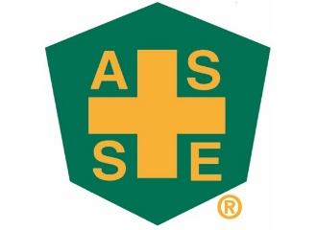
Northern Ohio and
Greater Detroit Chapters
SPONSORED BY:
